Historical ~ Musical ~ Visual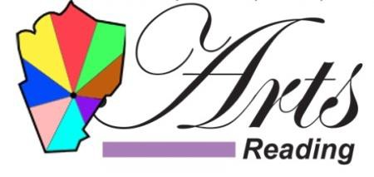Literary ~ Theatre ~ Community

Fundraiser to Benefit Arts Reading, Inc.!
WHEN: September 8, 2023
WHERE: MANDARIN READING, 296 Salem Street, Reading, MA 01867
TIME: 11:30 AM-9:30 PM
Go to our website, www.artsreadinginc.org, to download a coupon to present to your server before you order. When you do, 20% of your bill will be donated to Arts Reading, Inc. Also, please “Like” our Facebook page, www.facebook.com/ArtsReadingMA.
The coupon is good for both dining-in and take-out.
And please join us for our 5th annual Arts and Culture Festival on the Reading Town Common on October 14th from 10 am-2 pm. Rain date October 15th from 1-5 pm.
Our 2023-2024 members: Colonial Chorus Players, Woburn Guild of Artists, Reading Community Singers, Corbett Fine Art, Quannapowitt Players, Reading Antiquarian Society, Everett and Ginny Blodgett, Reading Historical Commission, and Reading Public Library.

